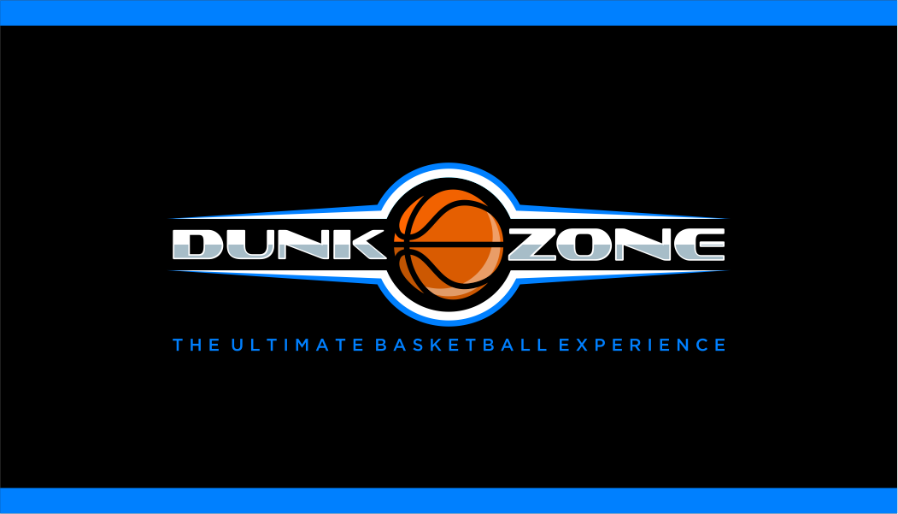

Assumption of Risks, Release of Liability, Waiver of Claims and Indemnity Agreement

IN EXCHANGE FOR Dunk Zone – The Ultimate Basketball Experience (hereinafter “Dunk Zone”) allowing me and/or my child to participate in a 3 x 3 basketball tournament, skills challenge; and, NBA All Star game viewing party, and related activities (hereinafter “Dunk Zone event’), I agree as follows:
- I understand and voluntarily accept the risks associated with the sport of basketball and other activities during the Dunk Zone event. I understand that such risks simply cannot be eliminated without jeopardizing the essential qualities of the activities. Dunk Zone employees and volunteers seek to create a safe environment, but they may give incomplete warnings or instructions. They cannot watch all participants at all times and the equipment being used might malfunction.

- I VOLUNTARILY ACCEPT AND ASSUME ALL OF THE RISKS ASSOCIATED WITH BASKETBALL AND OTHER RELATED ACTIVITIES DURING THE DUNK ZONE EVENT AND I CHOOSE TO PARTICIPATE DESPITE THE RISKS.

- If I am signing this Agreement on behalf of my child or children, I confirm that I have assessed the risks associated with Dunk Zone activities, in light of the specific abilities and circumstances of my child, and I VOLUNTARILY ALLOW MY CHILD OR CHILDREN TO PARTICIPATE in the Dunk Zone event AND ACCEPT ANY RISKS.

- I agree to GIVE UP MY RIGHT TO SUE DUNK ZONE AND WAIVE ALL CLAIMS For any damages or expenses that I or my family or estate may suffer or incur as a result of our participation in the Dunk Zone event, DUE TO ANY CAUSE WHATSOEVER, including Dunk Zone’s negligence, the failure to warn or protect me from risks, breach of contract, breach of any other duty of care, or breach of the Occupiers’ Liability Act, R.S.O. 1990, c. O.2.

- I agree to hold harmless and indemnify Dunk Zone from any and all liability for any damage, expense, injury or death caused to any third party as a result of my, or my child’s participation in the Dunk Zone event.

- If I am signing this Agreement on behalf of a child, I confirm that I am the child’s parent or legal guardian, or that I otherwise have legal authority to sign this Agreement on behalf of the child.

- I confirm that I have had sufficient opportunity to read this entire Agreement and did in fact read it and have understood its’ terms and AGREE TO BE BOUND by the terms of this Agreement.

I understand that in this agreement Dunk Zone, all related companies, affiliates, employees, volunteers, agents, directors and/or officers.

Signature _________________________________________________________________

Date _____________________________________________________________________

Parent/Legal Guardian/Power of Attorney/Participant (18 or older)
Name: ________________________________________________
Birth Date: _____________________________________________
Address: _______________________________________________
Phone Number: _________________________________________
Email: _________________________________________________
Minor Participant: _______________________________________

